• Hindi responsive sa mobile

• Kapag nasa dulo tapos nag scroll nagiging nalalagay sa top right yung hamburger icon pero kapag nag scroll up sa taas nawawala at napo-position sa pinaka right kaya hindi nagiging responsive ang page.

• May mga placeholder texts kapa like fgfgfgfh

• May mga broken images tapos off din yung mga positioning ng cards for me on mobile better to have it in a single row nalang and positioned center/middle instead of left and right.

Hero Section Feedback:

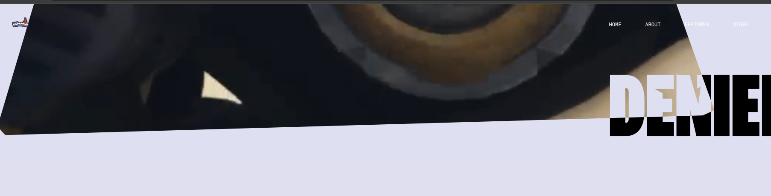•you can accompany this with a second solid color that is offset by around 12 or 16px towards bottom and right or left.

•give that a similar outro motion

Navbar Feedback:

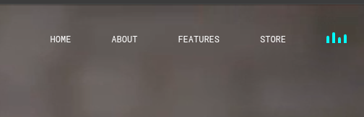

•but slightly staggered to that of the video container

•that way it doesnt just stick out of the background as it slides out

you can also give that a gradually fading opacity

this bit needs work

it just blends in the moment you scroll

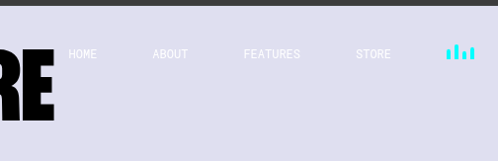

About Feedback:

oh yeah here's what i mean with that visual aesthetic, keep it consistent to this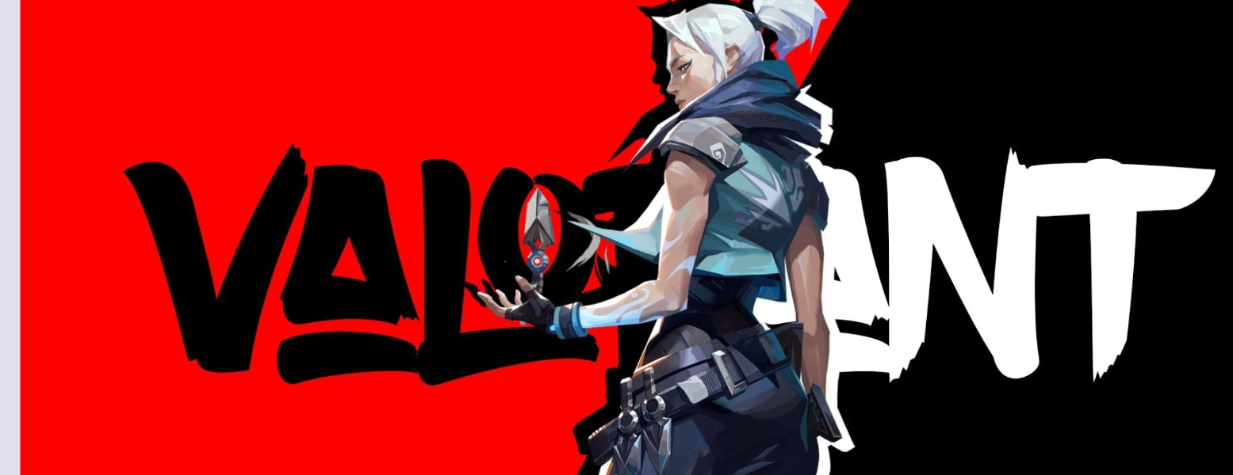

but try other typefaces for this one

Footer Feedback:

u can do better

design and readability for this:



ADDITIONAL FEEDBACKS:

afterwards you can deal with the layout and technical issues if youre after aesthetic more

right now it looks like you fished these out from somewhere randomly

you also probably need to work on your typography fundamentals, also potentially color contrasts

better look for reference na tugma sa theme ng game mo. u can use behance, dribble para maghanap ng reference